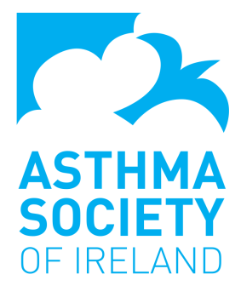
Asthma Youth Champions Application Form

Name of School:
Address:
Contact details:
Teacher who will be co-ordinating the programme:

Our school would like to be selected to participate in the Asthma Youth Champions programme because: ………………..

The Asthma Society of Ireland (ASI) is a national charity, we are dedicated and committed to empowering Ireland’s 470,000 people with asthma to gain control over their asthma by providing them and their families with information, education, support and services. Our focus is to represent asthma suffers and work together to improve health outcomes. We continuously actively engage with the public, healthcare professionals, the government, third parties and stakeholders to ensure that asthma is high on the list of priorities of policy makers and politicians and in public consciousness.

